Underground Mathematics: supporting teachers to develop students’ mathematical thinking and problem-solving

Anna Baker, Paul Brown, Julian Gilbey, Tabitha Gould,
Elizabeth Kimber, University of Cambridge

Corresponding author: E. Kimber, ek416@cam.ac.uk

Abstract
Underground Mathematics provides a large collection of online resources aimed at supporting effective problem-solving in A level mathematics classrooms. These resources are built around a dual framework of mathematical content (presented through a tubemap) and pervasive ideas (concepts such as averages, symmetry and invariance). We explain how features of the resources have been designed to encourage students’ mathematical thinking and problem solving, and also describe the provision put in place on the website (undergroundmathematics.org) to support teachers to use the resources effectively.

1. Project background
1.1 UK post-16 mathematics
Teaching of mathematics at age 16-18 in England has been under scrutiny and subject to political change in recent years. The most common qualification for this age group is A level, which is an optional course of study usually completed in two years. Fears have been expressed that students are being poorly equipped to face mathematical disciplines in higher education due to a lack of in-depth understanding of the subject matter (Higton et al, 2012; Morgan, 2011). There has also been a culture of transmissionist approaches and ‘teaching to the test’ (Pampaka et al, 2012).
The structure and content of A level mathematics has recently been modified with teaching to the revised specification starting in 2017. There is an increased emphasis on problem solving, mathematical language, proof and mathematical modelling.

1.2. The project
Underground Mathematics (formerly the Cambridge Mathematics Education Project) was set up with an aim to help make post-16 mathematics a rich, coherent and stimulating experience for students and teachers. It was funded for five years starting in 2012 by the UK Department for Education and is currently hosted by the University of Cambridge. The project team has developed a suite of rich teaching resources for use in the classroom which are delivered free of charge via the website https://undergroundmathematics.org/.
The project’s underlying philosophy identifies mathematics as a coherent, connected subject which can be made accessible to all students by allowing them to grapple with problems and learn from their own mistakes. The project encourages collaborative classroom learning and deeper mathematical thinking and understanding (Mason, Burton & Stacey, 2010).
The development of the project was also informed by work with 45 partner schools across England, chosen to represent a range of different contexts and types of schools.

1.3 Resources developed by the project
The project team has designed and published over 250 resources to support classroom teaching, each containing tasks, suggestions, solutions and teacher notes. The tasks are designed to be used inclusively with mixed-ability classes, allowing students to learn different things or gain different insights while working at essentially the same task.
In addition, some 560 review questions have been published on the Underground Mathematics website, all with fully worked solutions. These are mainly past examination questions taken with permission from sources including the Cambridge Assessment archives and Oxford University Mathematics Aptitude Tests. The questions have been chosen to help draw out connections and stimulate deeper understanding.
The resources on the website are organised into topic-based stations on a tubemap in the style of the London Underground map. The design and structure of this and of the overarching themes known as pervasive ideas are explored in section 2. Extensive teacher support materials have been developed alongside the classroom resources and these are described in section 4.
In addition to the online teacher support, the project also provides face-to-face professional development, primarily in the form of courses delivered by MEI (Mathematics in Education and Industry).

2. Knowledge organisation: the tubemap and pervasive ideas
To emphasise the coherence and connectedness of mathematics, the resources are arranged around a thematic tubemap, challenging the common conception of the subject as an ordered sequence of weakly-related or distinct topics, broken up into modules. The lines on the tubemap pick up on five themes which are developed through the A level course: number, algebra, geometry, functions and calculus. Each station on the tubemap includes a coherent collection of resources focused around one broad topic related to the line or lines on which the station lies. These resources might include both pure and applied (mechanics or statistics) problems, and material relevant to both single and further mathematics A levels. The tubemap evolved over a period of about three years, helped in part by discussions with partner school teachers, until it reached its present form in early 2016, see Figure 1.
To further develop a coherent, connected understanding of mathematics, six pervasive ideas such as Averages and Transforming are highlighted throughout the site. These are overarching ideas in mathematics which should not be treated as discrete content, but as recurring themes that permeate the subject. For instance, finding a definite integral is an example of averaging and integrating by substitution can be thought of as transforming an object so as to look at it from another point of view. Many Underground Mathematics resources are designed to raise awareness of these ideas, offering opportunities for students and teachers to develop insight and build connections.

3. Rich resources
The resources on Underground Mathematics have a variety of styles and are categorised by resource type, such as Many ways problem and Building blocks. Each resource is usually made up of several sections, with typical section headings including Problem, Suggestion, Solution and Things you might have noticed. Resources are accompanied by teacher notes in which the designers share some of the overarching ideas from the resource, highlight key pedagogical design choices and suggest possible approaches to using the resource in the classroom.

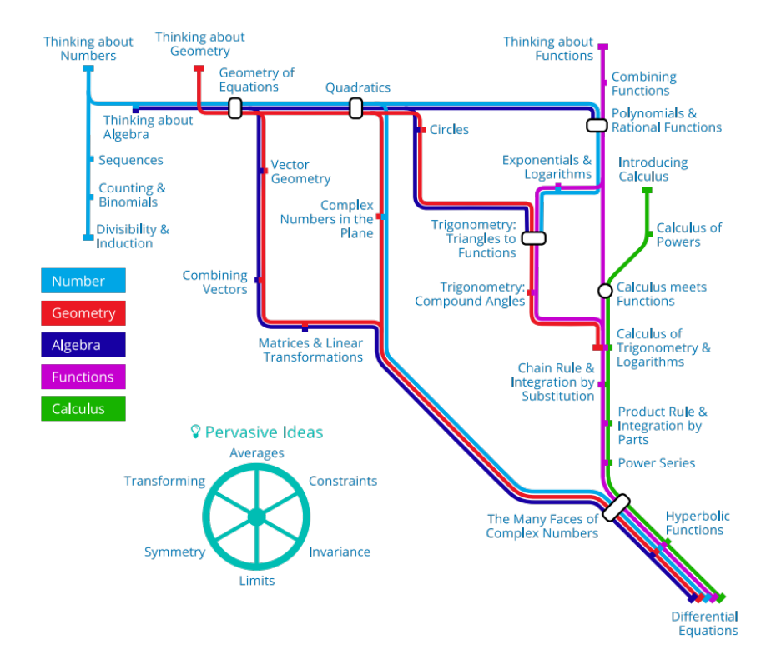
The Solutions or Things you might have noticed sections are an integral part of Underground Mathematics resources: they communicate some of the possible journeys that can be taken through a problem. Different starting points or alternative methods are often discussed, which can bring out connections to other areas of mathematics, including the pervasive ideas. The thinking that goes alongside a written mathematical solution is often made explicit. Thoughts and questions that encourage further thinking or reflection are included, and are often presented in a different style that is called a chalk box. These elements can help teachers prepare for using the problem, for example, by highlighting possible misconceptions, suggesting key questions or raising discussion points for the classroom.
Figure 1: The Underground Mathematics tubemap
3.1 An example of a resource (1): What else do you know?
This is a resource developed for the Calculus meets Functions station. The problem is based on an image, shown in Figure 2, which precedes any text and is designed to be the first thing to come to the attention of the teacher or student. It is suggested in the teacher notes that students should be encouraged to describe and reconstruct the diagram for themselves, so they become aware of the limited information provided and how this influences their own assumptions about other features of the graph. An example of this is the location of the local maximum of the curve. Common assumptions made by students are based upon the misconception that the $x$- and $y$-axes have the same scale, so that the height of this maximum is approximately $2$.

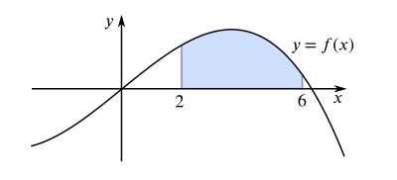
Figure 2: What else do you know?
The diagram in Figure 2 is immediately followed by the question “If you know that the area of the shaded region is 40 square units, which of the following can you evaluate?”
The following list of integrals is then presented for consideration.
$\int_{2}^{6}{(f(x) + 5)}dx$, $\int_{2}^{6}{\left(f\left(x\right)-3\right) dx}$, $\int_{0}^{4}{f\left(x+2\right) dx}$, $\int_{2}^{6}{f\left(x+2\right) dx}$,
$\int_{4}^{8}{f(x+2)} dx$, $\int_{2}^{6}{-f\left(x\right) dx}$, $\int_{2}^{6}{f\left(-x\right) dx}$
The question and selection of integrals are designed to encourage connections between algebraic and graphical representations of integration, and to provide opportunities for students to consider when and how each representation can be helpful. Ideally, students should be allowed to choose their first steps and their route through the problem, perhaps selecting a particular integral to consider, or taking a step back to think about similarities and differences between the integrals in the list. The order of the integrals in the list is intended to provoke student questions such as “What could I do first?”, “Why might I do that?”, and “What could I do next?”. Teachers are encouraged to ask students to explain and reflect on these initial choices at some point in the lesson and this is highlighted within the teacher notes.
It is expected that students will be asked to justify their decisions and answers. To reinforce this, the list of integrals is followed by the question “If there are any that you cannot evaluate, what additional information would you need in order to do so?” encouraging students not to dismiss those integrals that they cannot initially see how to tackle. Each of the proposed integrals has been chosen to challenge particular assumptions and possible misconceptions. As an example, the second integral, $\int_{2}^{6}{(f\left(x\right)-3)} dx$, could be handled algebraically as $\int_{2}^{6}{f\left(x\right) dx}- \int_{2}^{6}{3 dx }$. If students are also encouraged to represent the integral graphically and think about this as a vertical translation then they may, individually or collectively as a whole class, recognise that there are different diagrams that can be drawn. These possibilities are highlighted in the Solution section of this resource, see Figure 3, along with the accompanying questions “Does it matter which of the four images is correct in this scenario?” and “Will each image give a different result?”
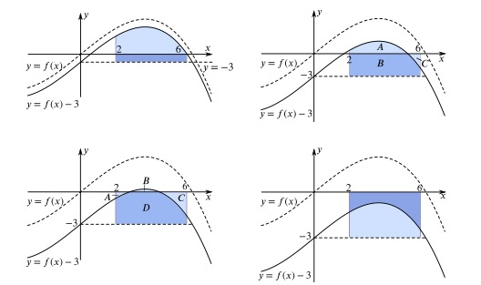
The Solution section is designed to raise further awareness of the particular assumptions and misconceptions that can be discussed with each integral. Diagrams, similar to those in Figure 3, are designed to be used as a potential stimulus for discussion in the classroom, emphasising the effects of vertical and horizontal translations.
Figure 3: Possible diagrams for the translated graph
This problem also presents two follow-up questions. The first challenges students to find the value of the constant $k$ for which $\int_{2}^{6}{(f(x) + k)}dx= 0$. This is designed to require students to think slightly differently, working from the value of the integral back to the possible transformation of $f(x)$ that would lead to it. The decision to propose a vertical translation of $f(x)$ is intended to encourage connections between this question and the first two integrals on the original list. More interesting perhaps is the choice of the value of the integral to be zero, as graphically students could realise that they will need equal areas above and below the $x$-axis in the given region. This is another opportunity to reinforce the distinction between the area “between” a curve and the $x$-axis and the value of the definite integral. A second follow-up question is designed to encourage deeper thinking about the nature of the function originally considered. Students are invited to consider how their approaches and conclusions might change if $f(x)$ were a linear function.

3.2 An example of a resource (2): Name that graph again
This is a resource that is part of the Combining Functions station. The problem is presented using the diagram in Figure 4 along with the question “In how many ways can you identify an equation for this parabola?”, which is a typical style of question in Underground Mathematics resources. This explicitly encourages students and teachers to focus on routes through a problem rather than the answer itself. The curve not crossing the $x$-axis and the lack of labelling on the axes means that students’ focus is directed to the three labelled points. These points have been carefully chosen to support the multiple approaches to the problem and to encourage thinking about the symmetry of the graph.
Underneath the stated problem is a button entitled “Have you thought about...?” which contains a concealed image and questions that encourage thinking about transformations, as shown in Figure 5. This is an example of how pervasive ideas are highlighted. Work with students shows that they are unlikely to take this approach, so showing that Transforming can be a powerful tool here provides an opportunity to encourage different ways of thinking and to make connections. The concealed text has been designed to support students through the use of diagrams and questions rather than explicit statements or hints. The diagram is given first so there is an opportunity for students to notice something for themselves, before being supported in their thinking by the prompting questions. This is a common approach throughout Underground Mathematics, and not only provides specific support in this instance, but also models a process of asking yourself questions about the mathematics you have been presented with in order to move forward.
Figure 4: Name that graph again
Figure 5: “Name that graph again” follow-on questions
The second section in Name that graph again is called Student starting points and contains four examples of partially completed student work. While there are many purposes for sharing sample student work in the classroom (Evans and Swan, 2014), the particular instruction given here is “For each approach, try to work out what they were doing and attempt to continue their work to reach a solution.” Exposing students to different approaches and asking them to come up with the reasoning behind them supports our aim of helping students to understand that there is rarely only one correct way to tackle a mathematical problem. Each example contains the questions, “What is this student doing? Why are they doing that? What could they do next?” (Evans and Swan, 2015). They are provided to help students reflect on the approach and complete the example. If students can internalise these questions, and begin to pose them routinely as they work on mathematical problems, then they are more likely to be able to communicate their thinking and make more conscious and productive decisions about their approach.

4. Further supporting teachers
Further support materials have been developed to help embed the use of Underground Mathematics resources in teachers’ A level practice, and to counter concerns that Underground tasks are only suitable for enrichment or only for some students. These materials are housed in an area of the website dedicated to teacher support and CPD, called Your mathematical classroom. This area includes detailed teacher notes and videos in Resources in action, and small collections or bundles of resources, which are designed to support particular aspects of teaching, such as asking questions or using student work as a resource. There are also recordings of webinars and a blog containing teachers’ descriptions of how they have used Underground Mathematics tasks. We describe two sections of Your mathematical classroom in more detail here.

4.1 Resources in action - support materials for teachers
The collaborative use of rich tasks creates a complex learning environment in which teachers have to notice and respond to students’ ideas. Feedback at a partner schools teacher workshop in March 2014 included requests for ”More in depth teachers notes on each activity”, and one teacher commented “Perhaps I am more ready to challenge my students now I have had the opportunity to see how other teachers have used these resources”. In response to this feedback, detailed support materials or Resources in action were developed for four resources in collaboration with partner school teachers (Major et al, 2015). Resources in action include preliminary and follow-up tasks, suggested ways of using the resource, and details of opportunities for learning, such as pervasive ideas, connections students might make, and issues or misconceptions that may arise. The notes also include descriptions of mathematical behaviour to look out for.
Sample student work and video clips of students working on the tasks were added to Resources in action in 2015 (see, for example, undergroundmathematics.org/thinking-about-functions/two-way-functions-teacher-support). For our purposes, classroom video offers teachers an opportunity to observe students collaborating on these rich tasks. Using video to support teachers to notice classroom interactions presents particular design challenges, especially in an online environment. The video pages include prompts to encourage analysis of student thinking and how this could be related to teachers’ actions. Further video clips show interviews with teachers and students to convey some of the context of the classroom episodes. In addition to the original four Resources in action, video pages have been developed for a larger collection of resources.
The inclusion of sample student work in Resources in action was intended to help teachers anticipate how students might respond to tasks, and reflect on the affordances of different approaches. For example, the sample student work for the resource Discriminating is intended to convey the power of a graphical approach because previous use of this resource had shown that most students and teachers took a purely algebraic approach. Further use of student work is made in the bundle entitled Using student work as a resource.

4.2 Bundles – developing mathematical thinking
A bundle is a collection of about 5 resources from different stations or topics, which collectively address a certain aspect of mathematical thinking or teaching. For example, the first bundle of resources is designed to be used at the start of an A level course to help students build resilience and to promote mathematical habits such as asking questions, drawing on previous experience, justifying ideas, and communicating effectively about mathematics. Other bundles focus on making use of students’ work in lessons and asking questions in the classroom. By grouping resources from different stations in this way, bundles offer an alternative view of how Underground Mathematics resources can support the development of teachers’ practice and students’ mathematical thinking. The resources are accompanied by text outlining the purpose of the bundle and suggestions for how it could be used with students. In the academic year 2016-2017, the publication of each bundle was followed by a related webinar, a recording of which is available online and linked from the bundle page.
It is envisaged that Resources in action and bundles could support teachers to reflect on practice individually and also be used in departmental CPD, providing opportunities to share planning and reflections on using Underground Mathematics resources with students. These materials have also been used in face-to-face CPD with teachers from over 400 schools since 2015 and webinars have been viewed by over 350 website users.

References
Evans, S. and Swan, M. (2014). Developing students’ strategies for problem solving in mathematics: the role of pre-designed “sample student work”. Educational Designer, 2(7).
Evans, S. and Swan, M., (2015). Developing student questioning when problem solving: The role of sample student responses. In CERME 9-Ninth Congress of the European Society for Research in Mathematics Education (pp. 3015-3021).
Higton, J., Noble, J., Pope, S., Boal, N., Ginnis, S., Donaldson, R. and Greevy, H. (2012). Fit for purpose?: the view of the higher education sector, teachers and employers on the suitability of A levels.
Major, L., Watson, S. and Kimber, E., 2015. Developing instructional and pedagogical design for the Cambridge Mathematics Education Project: A Design-based approach. Proceedings of British Society for Research into Learning Mathematics (BSRLM), 35(2).
Mason, J., Burton, L., & Stacey, K. (2010). Thinking Mathematically (2nd ed.). Harlow: Prentice Hall.
Morgan, B. (2011). Mind the Gap: Mathematics and the transition from A-levels to physics and engineering degrees'. EdComs, Institute of Physics, pp.1-26.
Pampaka, M., Williams, J., Hutcheson, G., Wake, G., Black, L., Davis, P. and Hernandez‐Martinez, P., (2012). The association between mathematics pedagogy and learners’ dispositions for university study. British Educational Research Journal, 38(3), pp.473-496.

