Transition into Higher Education: Universities influence on schools provision for AS/A level Maths and Further Maths

Kevin Lord, MEI, Stephen Lee, MEI

Abstract
The pool of prospective students with AS and A level Mathematics and Further Mathematics has grown over the last 10 years. Data from UCAS shows that the proportion of students starting degree courses with these qualifications has increased significantly.
However, recent changes to post-16 funding and to AS and A level specifications are beginning to have an impact on the number and range of A level subjects that students can choose. Some schools and colleges no longer allow students to take AS examinations at the end of Year 12 and some have limited students to taking just 3 A level subjects.
This paper considers analysis undertaken by the FMSP and partners, into:
• Increases in provision and participation in the mathematics A levels;
• Patterns of entry for students taking A level subjects, particularly 4 or more;
• A level Mathematics and Further Mathematics qualifications of undergraduates starting degree courses;
• Entry requirements in relation to mathematics A levels for a range of degree courses.
The findings provide a picture of the current situation regarding the supply of students with A level mathematics qualifications at a time when A level provision is changing rapidly. Higher Education plays a significant role in influencing students’ choice of A level subjects and thus the range of subjects offered by sixth forms. Clear information is needed from universities about the importance of mathematics for degree study in order to provide the necessary ‘demand pull’ to maintain and grow uptake in AS and A level Mathematics and Further Mathematics.

1. Increases in provision and participation in the mathematics A levels

1.1. Participation in A level Mathematics
In 2016 over 85 000 students entered for A level Mathematics in England, an increase of 78% since 2005 (source: www.jcq.org.uk). Mathematics has had the highest number of entries of any A level subject for the last 3 years. One in five students taking AS/A levels in state-funded schools and colleges is entered for A level Mathematics. However it is still the case that male students are twice as likely to take A level Mathematics as female students, 29.5% of the A level cohort for males compared with 15.0% for female students (source: DfE Maths and science tables SFR05/2017).
1.2. Participation in A level Further Mathematics
The number of students taking AS and A level Further Mathematics has increased each year for the past 13 years, doubling in the last 10 years. In 2016, despite a decrease in the size of the overall 16-19 cohort, entries for A level Further Mathematics in England increased by 1.9% to 14 566 students, one of only a very small number of subject that increased. More students took A level Further Mathematics than subjects such as law, PE, design and technology, or any of the modern foreign languages. 3.5% of the students taking AS/A levels in 2016, attending state-funded schools and colleges, took A level Further Mathematics. However, male students are over 3 times more likely to study further mathematics than female students.
1.3. Provision for the mathematics A levels
Almost all schools and colleges that offer A level programmes offer the opportunity for students to take A level Mathematics. In 2016 there were 2246 state-funded schools and colleges that had at least one student entered for at least one A level subject (source: DfE School Performance Data 2017). Of these, 96% had a student entered for A level Mathematics, the highest proportion of any A level subject. The mean entry per state-funded centre was 28 students.
Figure 1 shows a comparison of the proportion of state-funded schools and colleges that had entries for different A level subjects.
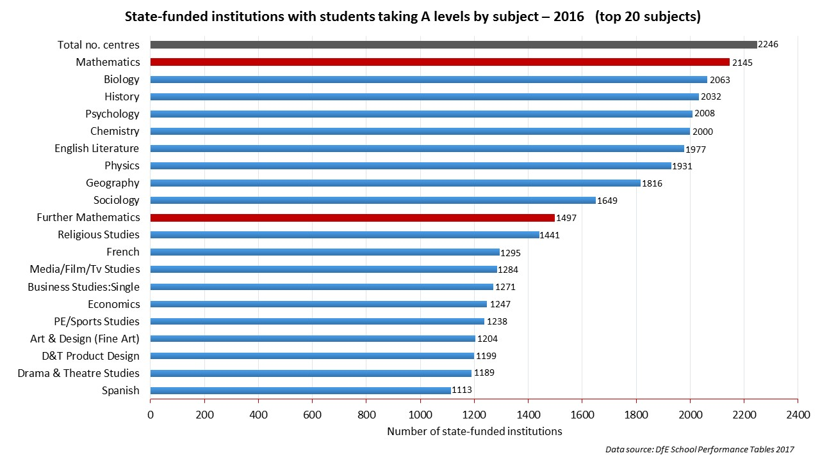
Figure 1 State-funded schools and colleges that had entries for different A level subjects
The opportunities for students to study Further Mathematics in state-funded institutions have never been better and are comparable with many other A level subjects – Further Mathematics is ranked 10th in the chart above. This access has changed over the last decade – the proportion of state-funded schools and colleges that had entries for both A level Mathematics and Further Mathematics has increased from 40% in 2004 to 70% in 2016.
Whilst there is much wider access to tuition for Further Mathematics, the number of entries per centre (mean of 7 in state-funded) is lower than many other subjects. Schools and colleges are facing financial pressures which are leading to reduction in the curriculum offered and subjects, such as Further Mathematics, with small class sizes are threatened. These concerns will be discussed further in the next section, which considers the patterns of entries for A level students.

2. Patterns of entry for students taking more than 3 A level subjects

The changes to post-16 funding (www.gov.uk/guidance/16-to-19-funding-how-it-works) and curriculum that were introduced in 2015 (www.tes.com/news/school-news/breaking-news/new-maths-gcse-causes-drop-a-level-applications) are already having an impact on the subject choices offered to Year 12 and 13 students in England. The FMSP has been contacted by teachers from schools and colleges where provision for AS level Mathematics, and/or AS and A level Further Mathematics are threatened with being removed from the curriculum offer.
The new post-16 funding arrangements now base funding on the number of students following a full programme of study (approximately 600 hours) and no longer on the number of subjects taken. In addition one of the reforms to A level qualifications is to decouple the AS and A level qualifications, see Glaister (2017). Hence grades/marks achieved for AS level no longer count towards the A level grade. These changes could have a significant impact on the provision for and uptake of AS and A level Mathematics and Further Mathematics.
Following a survey of 108 schools and colleges in March 2016 by FMSP Area Coordinators, in which 40% of institutions indicated that the A level offer had reduced to 3 A levels for the majority of students, the FMSP commissioned the Centre for Development and Research in Education at Sheffield Hallam University to investigate the pattern of entries in respect to Mathematics and Further Mathematics using the National Pupil Database.
Table 1 shows the number of A levels taken for three different Key Stage 5 student populations. First, students recorded as taking any A level; second, students who took A level Mathematics; and third, students who took A level Further Mathematics in 2014/15.
Table 1 Recorded A level entries (2014/15) - Excluding the General Studies A level
Number of A levels Taken | % students taking any A level | % students taking A level  Mathematics | % students taking A level  Further Mathematics
1 or 2 | 30% | 9% | 2%
3 | 64% | 74% | 46%
4 or more | 6% | 17% | 52%
Total N | 223,512 | 60,311 | 11,008

The data show that A level Further Mathematics is far more prevalent as a “4th subject” than other subjects overall. 52% of students taking Further Mathematics did so as part of a programme of 4 or more A level subjects. This is a particularly stark finding, given that the changes to the funding and curriculum detailed earlier have led to teachers citing that schools and colleges are restricting students in Year 12 to studying 3 A levels over 2 years, rather than the pattern which has been prevalent since 2000 of taking 4 AS subjects in Year 12, reducing to 3 A levels in Year 13.

3. Qualifications of undergraduates starting degree courses
Mathematics in Education and Industry (MEI), who manage the FMSP, obtained a dataset from the Universities and Colleges Admissions Service (UCAS) relating to students entering university in 2016/17. This built on data previously collated and analysed. For Table 2 the 129 degree subject lines as classified by UCAS were analysed in respect to how many students were accepted onto a degree having studied A levels, and how many had studied A level Further Mathematics.
The data presented in table 2 shows the top 15 degree subject lines that had the largest percentage of those accepted with A levels that had A level Further Mathematics in 2016/17.

Table 2 Prior A level Further Mathematics (FM) qualifications for those entering a number of degrees
Code | Degree Subject Group  (detailed level) | (A)  Studied A levels | (B)  Studied A level FM | (C)  2016/17 |  | (D)  2013/14 | (E)  2005/06
G1 | Mathematics | 5080 | 3290 | 64.8% |  | 59.6% | 35.6%
GG | Combinations within Mathematical Sciences | 190 | 100 | 52.6% |  | 56.8% | 17.9%
Y | Combs of phys/math/comp sciences | 440 | 225 | 51.1% |  | 42.3% | 22.3%
F3 | Physics | 2755 | 1060 | 38.5% |  | 36.1% | 15.7%
H1 | General Engineering | 1870 | 525 | 28.1% |  | 25.9% | 8.8%
H4 | Aerospace Engineering | 1265 | 345 | 27.3% |  | 23.4% | 13.7%
H3 | Mechanical Engineering | 2960 | 765 | 25.8% |  | 22.5% | 11.1%
Y | Combs of phys/math science with arts/humanities/languages | 345 | 85 | 24.6% |  | 12.7% | 5.5%
HH | Combinations within Engineering | 260 | 60 | 23.1% |  | 23.7% | 6.6%
H6 | Electronic and Electrical Engineering | 1030 | 225 | 21.8% |  | 22.6% | 10.8%
Y | Combs of phys/math science with social studies/bus/law | 965 | 180 | 18.7% |  | 18.3% | 5.9%
Z | Combs of 3 subjects, or other general courses | 2940 | 525 | 17.9% |  | 20.5% | 8.9%
H8 | Chemical, Process and Energy Engineering | 1520 | 260 | 17.1% |  | 19.9% | 8.7%
Y | Combs of sciences with engineering/technology | 395 | 65 | 16.5% |  | 17.6% | 3.7%
I1 | Computer Science | 4785 | 765 | 16.0% |  | 11.6% | 3.6%

The more detailed description of the column headers A-E is:
(A) Total number of students accepted to course in 2016/17 who studied A levels
(B) Total number of students accepted to course in 2016/17 who studied A level Further Mathematics
(C) % of those accepted with A levels that had A level Further Mathematics in 2016/17
(D) % of those accepted with A levels that had A level Further Mathematics in 2013/14
(E) % of those accepted with A levels that had A level Further Mathematics in 2005/06
When comparing 2016/17 with the previous dataset for 2013/14, 10 of the 15 subject lines showed an increased percentage, and 5 showed a small decrease. However, all subject lines saw this percentage rise considerably since the records were first analysed in 2005/06, Computer Science having one of the largest proportional increases from 3.6% to 16%. It is also notable that Physics now has almost two in every five students (38.5%) accepted having studied A level Further Mathematics, when in 2005/06 this was 15.7%. Mathematics has the highest percentage of students entering with Further Mathematics, and it too has experienced a considerable increase, from 35.6% in 2005/06 to 64.8% in 2016/17.
A key outcome shown by the data is that students who have studied A level Further Mathematics find themselves going on to study degrees that span a wide and varied range of subjects. This at a time that the absolute numbers studying A level Further Mathematics has increased over the last decade.

4. Entry requirements in relation to mathematics A levels
The FMSP has been monitoring the A level entry requirements and statements about preferred qualifications for a range STEM degrees since 2014. The purpose of this review was to find evidence of clear signaling by universities of the importance of continued mathematical and statistical study post-16 in preparation for undertaking a degree. The FMSP has used the information when discussing with university admission tutors and heads of departments about the need for more explicit encouragement for A level mathematics qualifications.
In August 2016 the FMSP reviewed the entry requirements of 763 degree courses using university webpages and online prospectuses. As in previous reviews by the FMSP, each course was rated on a scale from 1 to 4 based on its requirement/preference for A level Mathematics and Further Mathematics as follows:
1 = required
2 = preferred or encouraged in text or through a differentiated offer
3 = mentioned (often in list of over 4 subjects, without specific preference)
4 = not mentioned
Table 3 Requirement of A level Maths/Further Maths for a selection of STEM disciplines
Degree Course | No. of courses reviewed | % A level Mathematics required | % A level Mathematics preferred or encouraged | % A level Further Mathematics required | % A level Further Mathematics preferred or encouraged
Mathematics G100 | 65 | 100% | 0% | 9% | 23%
Physics F300 | 44 | 100% | 0% | 4% | 16%
Aeronautical Engineering H400 | 27 | 100% | 0% | 4% | 7%
Chemical Engineering H800 | 25 | 96% | 0% | 0% | 8%
Mechanical Engineering H300 | 69 | 96% | 3% | 0% | 6%
Electrical Engineering H600 | 62 | 90% | 2% | 0% | 11%
Civil Engineering H200 | 54 | 89% | 7% | 0% | 6%
Computer Science G400 | 87 | 25% | 7% | 0% | 4%
Economics L100/L101 | 70 | 24% | 3% | 0% | 3%
Chemistry F100 | 51 | 14% | 4% | 0% | 0%
Biology C100 | 62 | 0% | 3% | 0% | 0%
Geography F800 | 57 | 0% | 2% | 0% | 0%
Psychology C800 | 90 | 0% | 0% | 0% | 0%

Table 3 is taken from analysis undertaken by the FMSP (2017). It’s evident that though many universities require A level Mathematics for various degrees, very few require A level Further Mathematics, or even indicate that they prefer or encourage it. The analysis also indicated that there had been little change overall in the encouragement of A level Mathematics or Further Mathematics in the degree entry/admission statements of these courses since 2014.

5. Conclusion
In this paper several pieces of analysis have been considered to provide insight into the transition from school/college to university. These included evidence of increases in provision and participation in the mathematics A levels; patterns of entry for students taking A level subjects, particularly 4 or more; A level Mathematics and Further Mathematics qualifications of undergraduates starting degree courses; degree entry requirements in relation to mathematics A levels for a range of courses.
Several related questions emerge in this strand of activity - what potential transition issues are there and how might they be tackled? And what support/infrastructure already exists and how might this be developed?
The funding and curriculum changes that are leading to a reduction in the number of subjects that students are routinely able to take in Year 12 could have a significant impact on participation in A level Further Mathematics, and to some extent for A level Mathematics. The FMSP continues to promote the importance of maintaining Further Mathematics provision and supports schools and colleges through the provision of teaching resources, tuition for students and professional development for teachers.
It is not possible to affect the actual funding and overarching curriculum and so the FMSP considers it vital for universities to provide a clear, strong message about the importance and usefulness of studying AS or A level Mathematics and Further Mathematics. Evidence of higher education’s support for mathematics is needed to sustain the growth in entries, and will:
• Support mathematics teachers in making a case to senior leaders in schools and colleges for maintaining opportunities for students to take AS and A level Further Mathematics and AS level Mathematics;
• Encourage students to continue with their study of mathematics post-16;
• Ensure the government continues to support provision for Further Mathematics, in particular AS level Further Mathematics.
Previous reports, such as Hillman (2014), have also stressed the need for clear signalling from universities to students and their teachers about the nature and extent of mathematical and statistical knowledge and skills needed in undergraduate degree programmes and a recommendation from universities of the benefits of continuing with mathematical/statistical study beyond the age of 16. Now is an important time for all stakeholders to reinforce the key messages about the importance of mathematics both for a wide range of careers and for progression to higher education.

References
FMSP (2017) Access to HE opening plenary March 2017. Available via http://furthermaths.org.uk/docs/Changes-A-level-maths&furthermaths-for-HEIs-Mar17.pdf [accessed 30/05/2017]
Glaister, P. (2017) AS and A levels in Mathematics and Further Mathematics are changing - are you ready? MSOR Connections, 15 (3). pp. 14-27. Available via https://journals.gre.ac.uk/index.php/msor/article/view/508/pdf [accessed 30 May 2017].
Hillman, J. (2014), Mathematics after 16: the state of play, challenges and ways ahead. Available via http://www.nuffieldfoundation.org/sites/default/files/files/Mathematics_after_16_v_FINAL.pdf [accessed 30/05/2017]

